**Nampi Bikes Booking Guide**

**Step1: (Click on Book Now)  
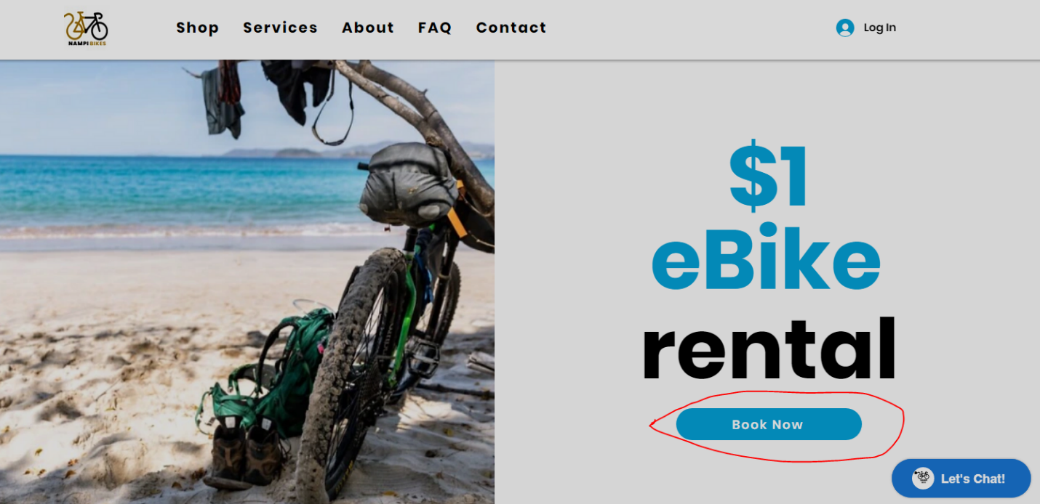  
  
Step2: (Click on Pickup Date)  
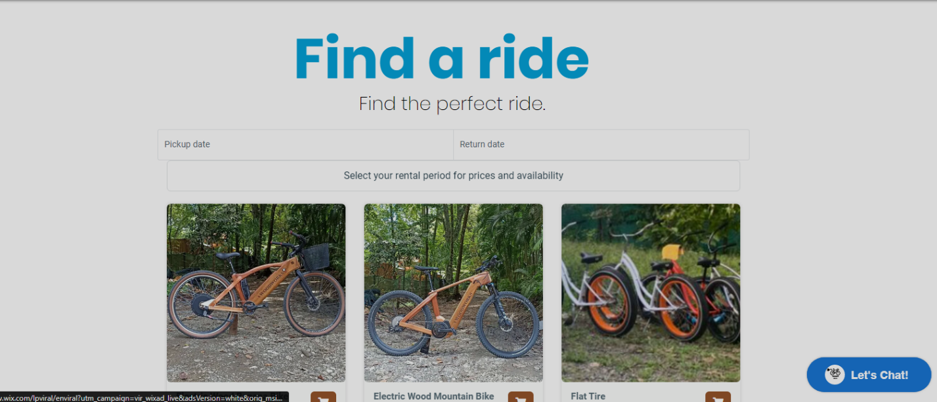**

**Step3: (Select Pickup Date)**

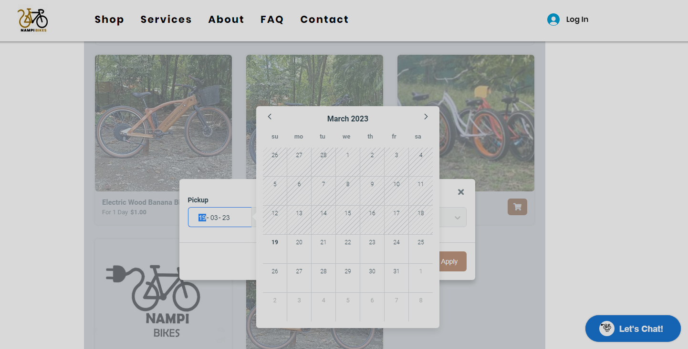

**Step4: (Select Return Date)**

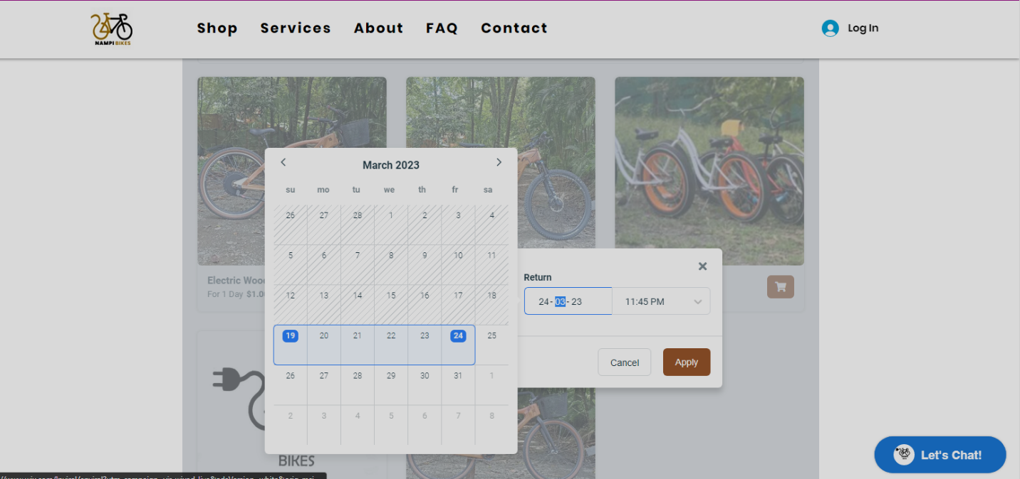

**Step5: (Select your Bike which is available)**

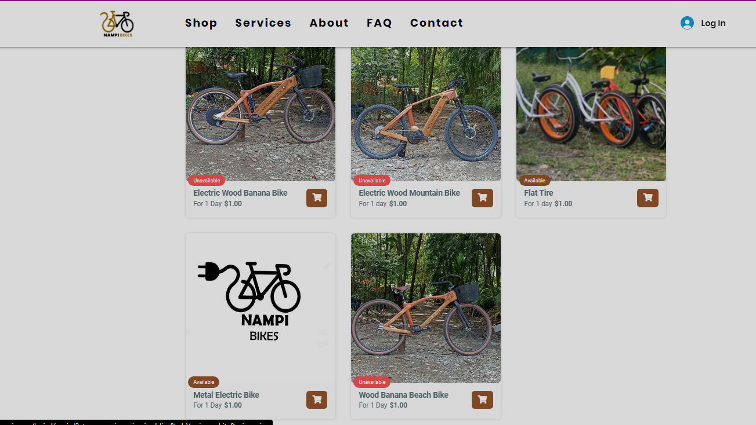

**Step6: (Click on Add to Cart)**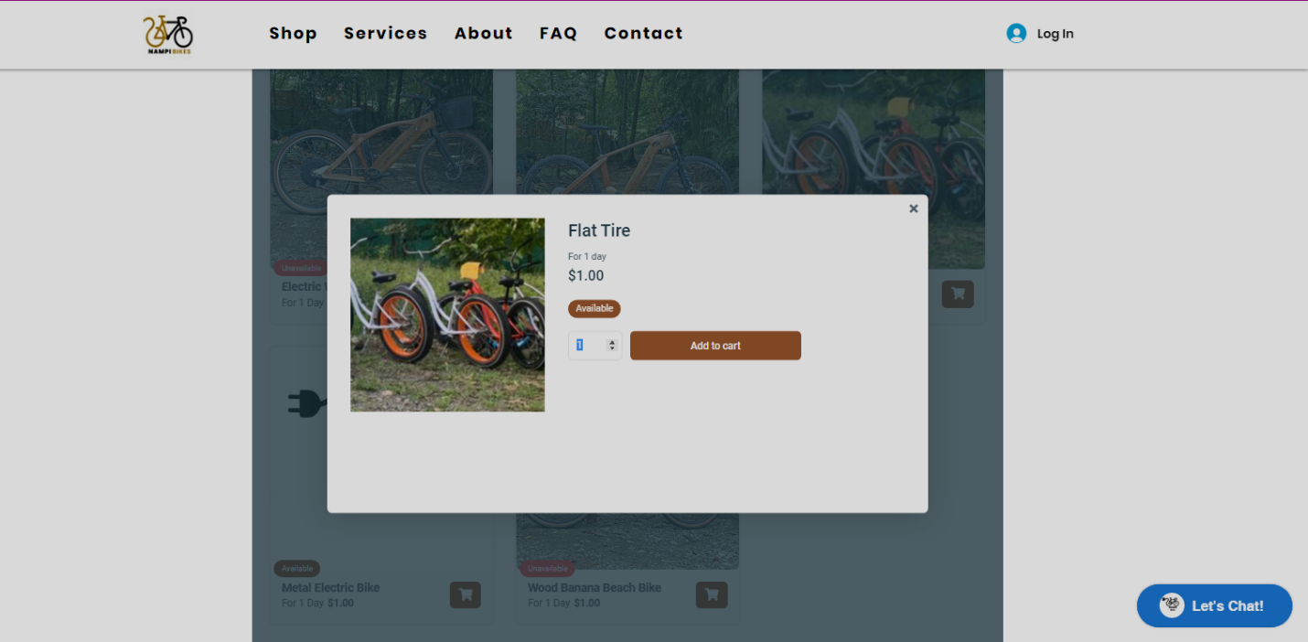

**Step7: (Click on Checkout)**

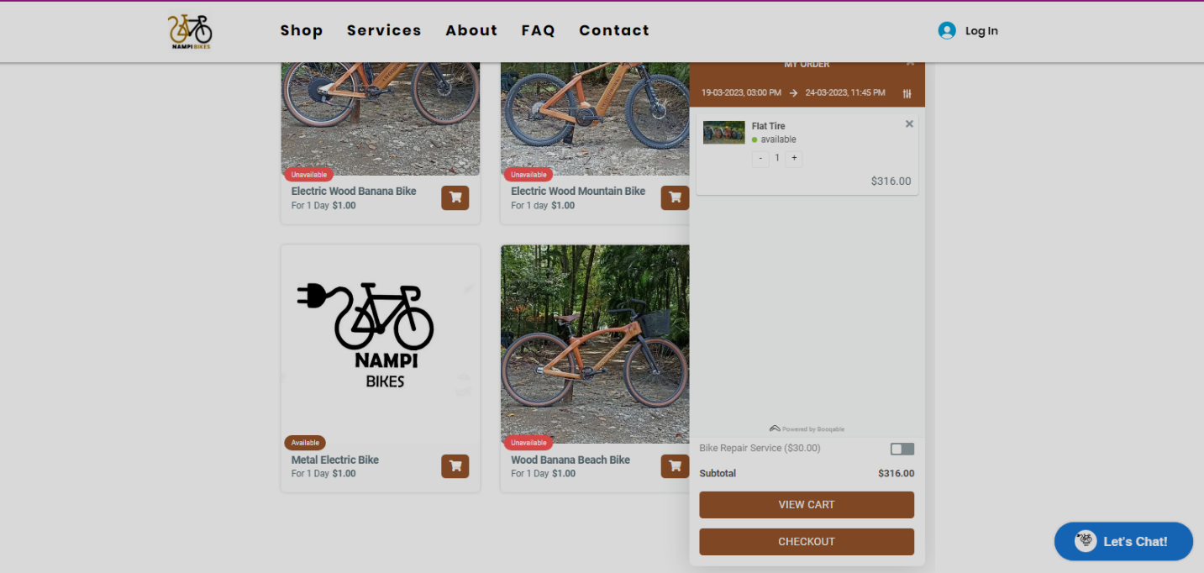

**Step8: (Fill out Checkout Details)**

